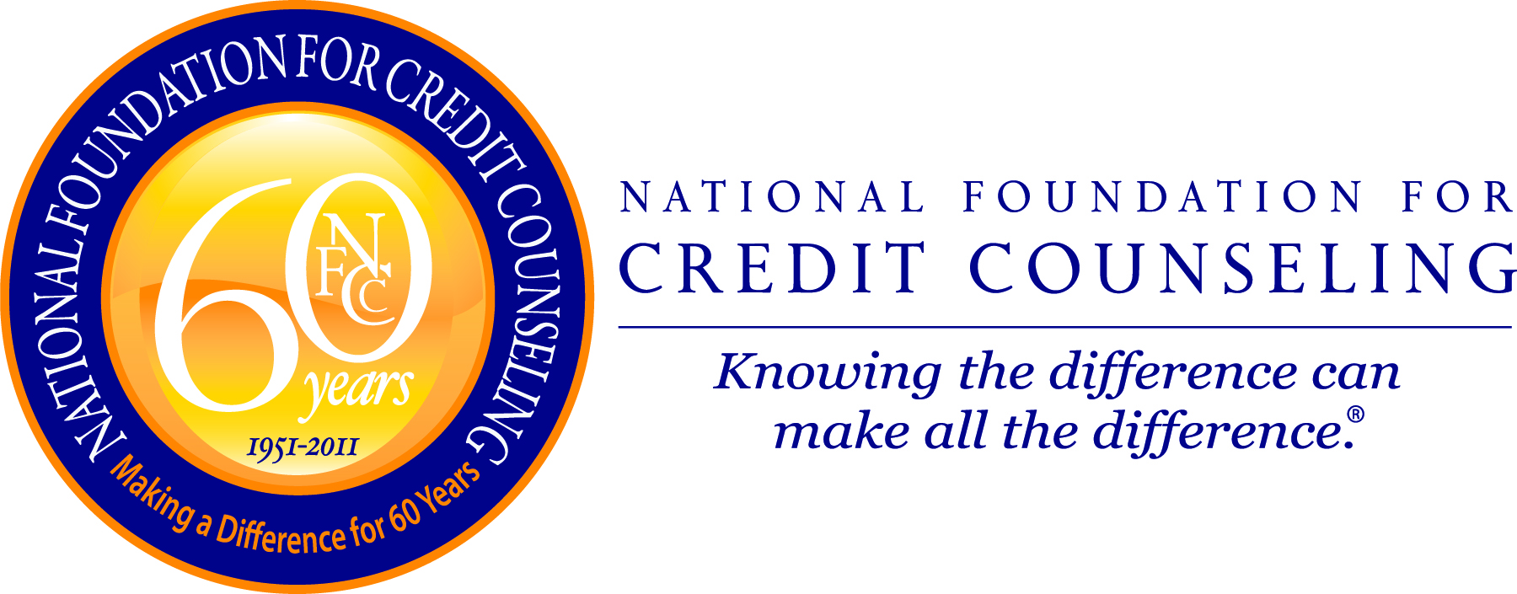

NFCC PRESS RELEASE
For Immediate Release
Contact:
May 2, 2011 Gail Cunningham
(940) 691-6322 - direct
(240) 672-2700 – cell
gcunningham@nfcc.org

POLL REVEALS THAT FINANCIAL DISTRESS
NEGATIVELY IMPACTS CONSUMERS
IN AREAS OTHER THAN FINANCE

Marriage and Health Categories Hardest Hit

Washington, DC – According to the National Foundation for Credit Counseling’s (NFCC) April online poll, financial distress is most harmful to your marriage and your health. Showing similar results, 27 percent of more than 1,400 respondents indicated that their marriage was experiencing the most stress as a result of their financial situation, while 24 percent said their health was suffering.

“Financial concerns stay with you 24 hours per day, seven days a week. They are there when you wake up and when you go to sleep, at work and at home,” said Gail Cunningham, spokesperson for the NFCC. “It is not surprising that this degree of prolonged financial stress manifests itself in areas other than our bank accounts.”

The problem is likely exacerbated by the length of time people have endured financial hardship, as the recession officially began in December of 2007, and was not declared officially over for 18 months, in June of 2008. In spite of the textbook definition confirming that the worst is behind us, many consumers are still not feeling any relief due to the continuing worries associated with the price of commodities, and the job and housing markets. Confirming this attitude, a recent Gallup survey revealed that more than half of Americans say the U.S. economy is in a recession or a depression in spite of what the economists tell us.

Not surprisingly, 14 percent of respondents indicated they felt significant stress related to their job. For those who are fortunate enough to be employed, they are likely working long hours, taking on extra responsibilities while accepting pay freezes and declining benefits, any of which could add to their level of discomfort.

-more-
Sixteen percent of those weighing in said their sleep had been impacted the most by their financial situation. This, of course, could lead to health problems, making those combined categories even more of a concern for individuals and America as a whole.

Parallel to the marriage category are the 13 percent who said their role as a parent was showing the most stress. Concerns related to the basics of life, things such as paying the rent or mortgage, putting food on the table and keeping the lights on can wear on a person and put significant strain on their home life, something the children cannot ignore.

The actual survey question and answers are as follows:

Financial distress can impact many areas of a person’s life. In which area are you feeling the most stress as a result of your financial situation? Is it your

Marriage = 27%

Role as a parent = 13%

Job = 14%

Sleep = 16%

Health = 24%

None = 6%

If you are experiencing stress related to your debt or other financial issues, reach out to a trained and certified credit counselor for help. To be automatically connected with the NFCC Member Agency closest to you, dial (800) 388-2227, or go online to www.DebtAdvice.org. For assistance in Spanish, dial (800) 682-9832.

Note: The NFCC’s April Financial Literacy Opinion Index was conducted via the homepage of the NFCC Web site (www.DebtAdvice.org) from April 1 - 30, 2011 and was answered by 1,404 individuals.
- 30 -

The National Foundation for Credit Counseling (NFCC), founded in 1951, is the nation’s largest and longest serving national nonprofit credit counseling organization. The NFCC’s mission is to promote the national agenda for financially responsible behavior and build capacity for its Members to deliver the highest quality financial education and counseling services. NFCC Members annually help over three million consumers through close to 800 community-based offices nationwide. For free and affordable confidential advice through a reputable NFCC Member, call (800) 388-2227, (en Español (800) 682-9832) or visit www.nfcc.org. Visit us on Facebook at http://www.facebook.com/NFCCDebtAdvice and on Twitter at http://twitter.com/NFCCDebtAdvice.

