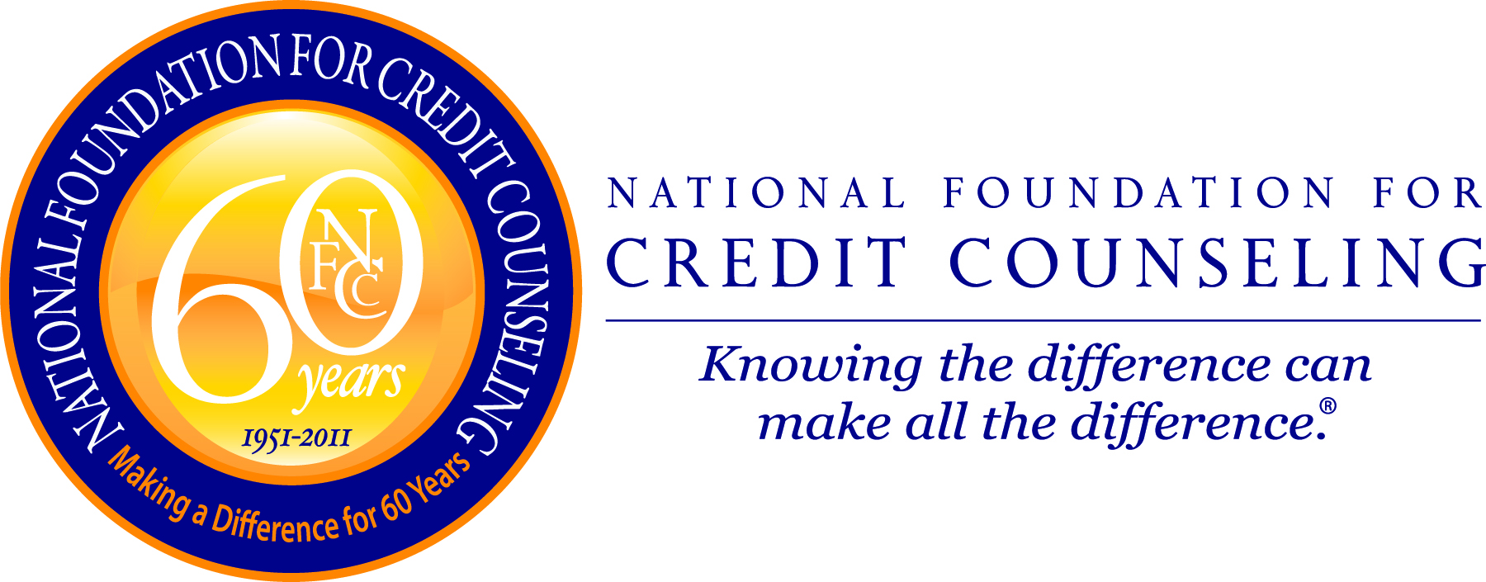

NFCC PRESS RELEASE
For Immediate Release
Contact:
September 1, 2011 Gail Cunningham
(202) 677-4355 - direct
(240) 672-2700 – cell
gcunningham@nfcc.org

AMERICANS STRONGLY VALUE
PAYING DOWN DEBT OVER SAVING

Washington, DC – According to the August poll hosted on the National Foundation for Credit Counseling (NFCC) website, 89 percent of more than 2,900 respondents value paying down debt over saving money.

“People often debate which is more important, to be debt free or to have a robust savings account, and the answer is both,” said Gail Cunningham, spokesperson for the NFCC. “As important as it is to handle debt responsibly, the truth of the matter is that the unplanned emergency is inevitable, and savvy consumers will recognize this and prepare for it.”

January 1959 was the first month that the Bureau of Economic Analysis provided savings data. According to that initial report, the personal savings rate in the United States at that point was 8.3 percent of disposable income, equating to the average person saving approximately one-month’s take-home income per year.

History has shown that the rate of savings increases during difficult economic times, as consumers begin to cut back on their purchases. Correspondingly, savings typically decline during good economic times as is evidenced by the rate of savings falling below 1.0 percent before the last recession which began at the end of 2007. Even though the savings rate has recently climbed to approximately 5 percent, it is far less than the savings in some years past.

Admittedly, it is difficult to save during times of inflation and job loss. The fact of the matter is that each person only has a certain amount of disposable income, and when he or she has to pay more for everyday commodities, it cuts into the amount available for saving, making a bad situation even worse.

Making people feel more comfortable with their lack of savings has been access to credit, with some using credit not only as a convenience, but as a piggy bank. “Credit replaced savings as the family’s safety net, with some arguing that savings was unnecessary since they could charge or borrow their way out of any unplanned event,” continued Cunningham.

Times are different now, and consumers know it, with the new normal for credit shaping up before our eyes. Access to credit has diminished totally for some, while credit lines have been lowered for others, making reliance on credit as a rescue tool in an emergency not an option for many.

Further, as the NFCC’s survey reflects, controlling debt has become paramount for consumers, with studies indicating that new purchases are more likely to be paid for with a debit card than credit, thus keeping personal debt at a manageable level and freeing up money for savings.

-more-
Consumers appear to have learned their lesson about over-spending. Now they need to focus on the other side of the equation: saving. The best use of the money that was previously going to pay off creditors is to begin or build up personal savings in the following five key areas:

- Rainy day fund - covers the everyday life emergencies such as home or vehicle maintenance, insurance co-pays and deductibles, etc.
- Income replacement account - sustains you in the event of a job loss, major medical event, divorce, etc.
- Downpayment for a mortgage – a significant downpayment will put you in a better buying position, as well as lower the amount you have to borrow
- Known future expenses – plan in advance for upcoming major expenses such as education, vehicles, vacations, etc.
- Retirement – start planning today to secure your tomorrow, as even small amounts of money invested over time can make the difference in how you live during your senior years
“In bad times, people save out of a fear of tomorrow, and in good times they spend as if there were no tomorrow,” said Cunningham. “To turn this savings/spending cycle into financial stability, consumers should recognize the unarguable importance of savings and develop a systematic plan to meet their personal savings goals.”

If you need help getting started, reach out to your local NFCC Member Agency. To be automatically connected to the Agency closest to you, dial (800) 388-2227, or to locate a counselor online go to www.DebtAdvice.org. For assistance in Spanish, dial (800) 682-9832.

The August poll question and results are as follows:

Which is more important to you?

- Paying down debt = 89%
- Increasing savings = 11%

Note: The NFCC’s August Financial Literacy Opinion Index was conducted via the homepage of the NFCC Web site (www.DebtAdvice.org) from August 1 - 31, 2011 and was answered by 2,928 individuals.
-30-

The National Foundation for Credit Counseling (NFCC), founded in 1951, is the nation’s largest and longest serving national nonprofit credit counseling organization. The NFCC’s mission is to promote the national agenda for financially responsible behavior, and build capacity for its members to deliver the highest-quality financial education and counseling services. NFCC Members annually help over three million consumers through close to 800 community-based offices nationwide. For free and affordable confidential advice through a reputable NFCC Member, call (800) 388-2227, (en Español (800) 682-9832) or visit www.nfcc.org. Visit us on Facebook: www.facebook.com/NFCCDebtAdvice, on Twitter: twitter.com/NFCCDebtAdvice, on YouTube: www.YouTube.com/NFCC09 and our blog: http://financialeducation.nfcc.org/.

